World Weather Analysis

1. The data shows a consistent relationship between the Lat distance and temperature. Cities close to the equator especially those within -10 to -40 Lat show the highest temperature of about 70 to 85deg F.

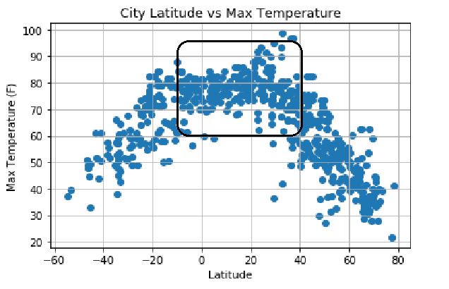

1. Latitude is also a factor to Humidity level on cities within -10 to 20 Lat.

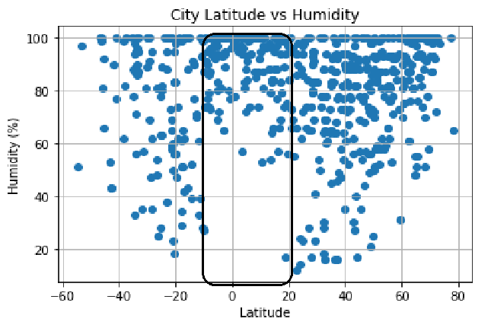

1. Cities’ Wind Speed and Cloudiness do not have direct relationship to their distance from the equator.

[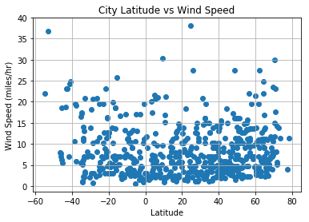](https://github.com/flauan/WorldWeather/blob/master/output_10_0.png)[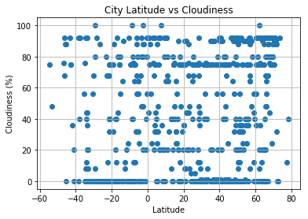](https://github.com/flauan/WorldWeather/blob/master/output_9_0.png)